AI Lab Report
Tasks 1–3: AI timeline, rule-based scholarship check, and the conversational test

Task 1: Timeline of AI Milestones
The entries below are in chronological order. This is a historical summary, not a model-training exercise.
Year / period | Event | Significance | Source
1950 | Alan Turing publishes "Computing Machinery and Intelligence" and proposes the imitation game. | It reframed "can machines think?" as a testable question about behaviour. | Turing (1950)
1956 | The Dartmouth summer workshop proposal is written and the term "artificial intelligence" enters use. | It is widely treated as the founding moment of AI as a research field. | McCarthy et al. (1955)
c. 1974–1980 (first AI winter) | After the critical Lighthill Report (1973), UK and US funding for AI research was cut back. | Early promises (e.g. machine translation) had not been met, and the period shows how hype followed by disappointment can stall a field. | Lighthill (1973); Russell & Norvig (2021)
1997 | IBM's Deep Blue defeats world chess champion Garry Kasparov in a match. | It showed a machine could beat the best human at a task long seen as a mark of intelligence, using search and special hardware. | Campbell, Hoane & Hsu (2002)
2012 | AlexNet, trained on GPUs using the ImageNet data set (about 1.2 million images), wins the ImageNet image-recognition contest by a large margin. | This is the modern compute-and-data milestone: large labelled data plus GPU computing made deep learning practical. | Krizhevsky, Sutskever & Hinton (2012)
2017 | Vaswani et al. introduce the Transformer architecture. | It became the basis of today's large language models and conversational systems. | Vaswani et al. (2017)

References
Campbell, M., Hoane, A. J., & Hsu, F.-H. (2002). Deep Blue. Artificial Intelligence, 134(1–2), 57–83.
Krizhevsky, A., Sutskever, I., & Hinton, G. E. (2012). ImageNet classification with deep convolutional neural networks. Advances in Neural Information Processing Systems, 25.
Lighthill, J. (1973). Artificial Intelligence: A General Survey. Science Research Council, UK.
McCarthy, J., Minsky, M. L., Rochester, N., & Shannon, C. E. (1955). A proposal for the Dartmouth Summer Research Project on Artificial Intelligence.
Russell, S., & Norvig, P. (2021). Artificial Intelligence: A Modern Approach (4th ed.), Chapter 1. Pearson.
Searle, J. R. (1980). Minds, brains, and programs. Behavioral and Brain Sciences, 3(3), 417–457.
Turing, A. M. (1950). Computing machinery and intelligence. Mind, 59(236), 433–460.
Vaswani, A., et al. (2017). Attention is all you need. Advances in Neural Information Processing Systems, 30.

Task 2: Rule-Based Scholarship Eligibility
Important: all thresholds in this task (score 70, attendance 75%, income 50,000) are synthetic lab assumptions. They are not real scholarship policy.
The original rule accepts an applicant if the score is at least 70 and the documents are complete. I kept both and added two named conditions:
- attendance_ok: attendance must be at least 75%.
- income_ok: yearly household income must be at most 50,000 (synthetic units).
An applicant is ELIGIBLE only if all four conditions are true. Otherwise the program reports exactly which conditions failed, which keeps the rules transparent.

Code
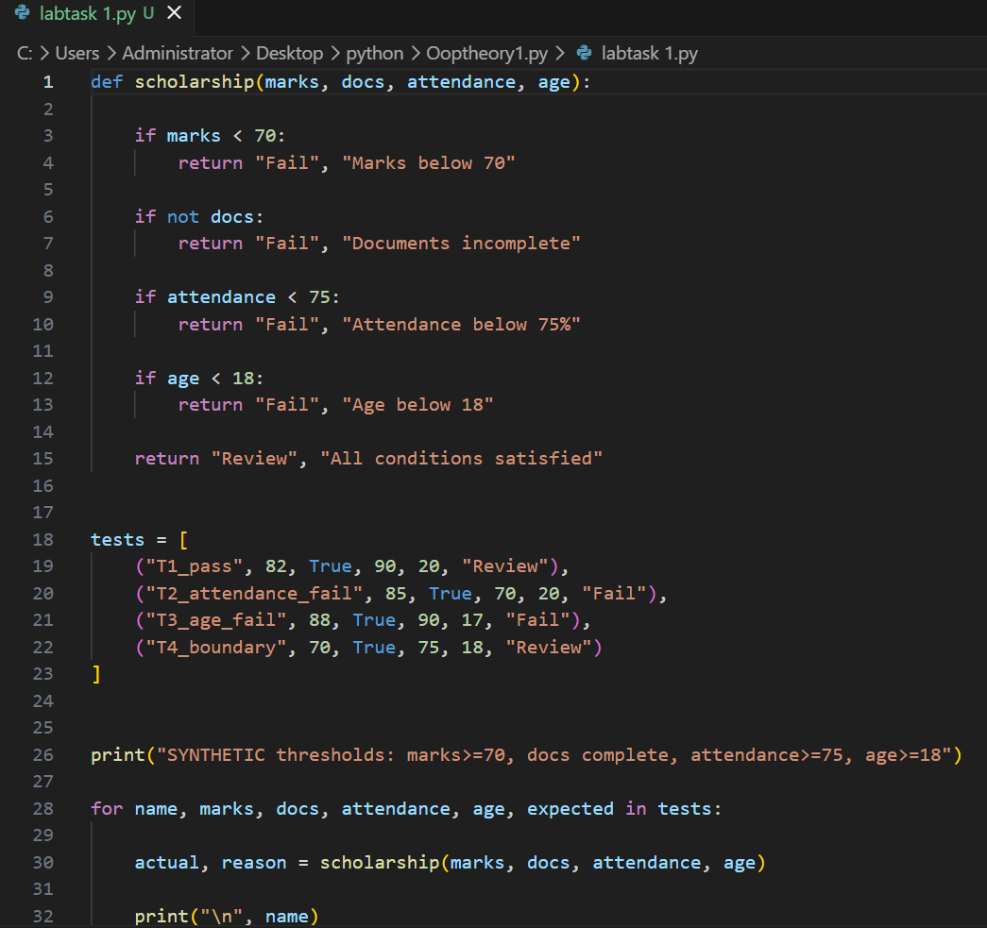
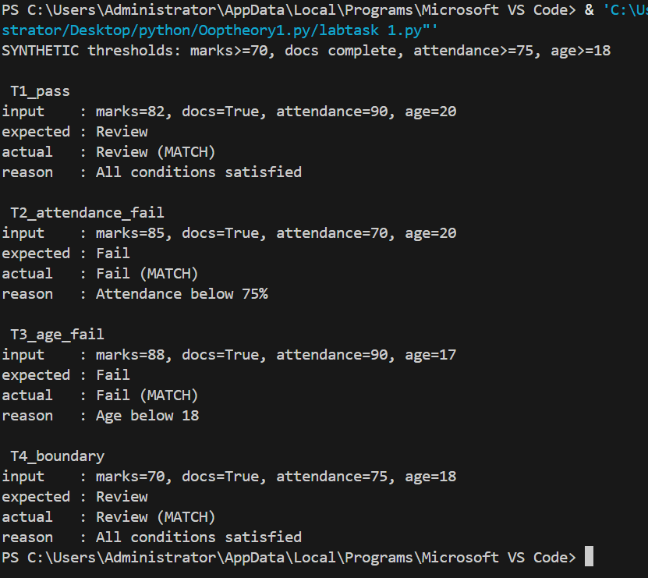

How the four test cases were chosen
There are exactly four cases, each with a different purpose. One case passes everything, one fails only the new attendance rule, one fails only the new income rule, and one sits exactly on the score threshold. Changing only one factor at a time means a failure points to a single rule. The expected result for each case was decided by hand before running the code.

Test results
Case | Input | Expected | Actual | Reason
1. Clear pass | score=85, documents_complete=True, attendance=90%, income=40000 | ELIGIBLE | ELIGIBLE | All four conditions met. Baseline: every condition is met, so the rules should accept.
2. Fails attendance_ok | score=85, documents_complete=True, attendance=60%, income=40000 | NOT ELIGIBLE | NOT ELIGIBLE | Failed: attendance_ok. Isolates the new attendance_ok rule: everything else passes, only attendance fails.
3. Fails income_ok | score=85, documents_complete=True, attendance=90%, income=65000 | NOT ELIGIBLE | NOT ELIGIBLE | Failed: income_ok. Isolates the new income_ok rule: everything else passes, only income fails.
4. Score boundary (exactly 70) | score=70, documents_complete=True, attendance=90%, income=40000 | ELIGIBLE | ELIGIBLE | All four conditions met. Tests the >= operator: a score of exactly 70 must pass, a common off-by-one error.

All four actual results matched the expected results.

Task 3: Passing a Conversational Test vs. General Intelligence
Scholarship case: imagine a chatbot that answers applicants' questions about the scholarship rules from Task 2.

What the conversational test observes
Turing (1950) proposed the imitation game, in which a judge talks to a machine and a human and tries to tell them apart. It observes only the machine's conversational behaviour. If the scholarship chatbot writes natural, polite answers that a judge cannot distinguish from a human adviser's, it would do well on this test.

What it does not establish
- Correctness: a fluent answer can still be wrong. The test does not check answers against the actual rules.
- Understanding: Searle (1980) argued that producing convincing language does not show a system understands it.
- Generality: success in one conversation says nothing about other tasks such as planning, perception or acting reliably in the real world.
- Reliability: a judge sees a few exchanges. It does not show the chatbot gives the same correct answer every time.

Example of fluent but incorrect reasoning
This is a hypothetical example written for this report, not a real transcript. An applicant with a score of exactly 70, complete documents, 90% attendance and income of 40,000 asks whether they qualify. The chatbot replies:
"Unfortunately a score of 70 only just misses out, because the rule requires a score above 70. I'm sorry, you are not eligible this time."
The reply sounds confident and human, but the rule says at least 70 (score >= 70), so the applicant is eligible (Test case 4 in Task 2). The language is fluent while the reasoning is wrong. A judge who only checks how natural the conversation feels could miss this error.

One additional test of reliable task performance
Decision-accuracy test: give the chatbot a set of 100 applicant records it has not seen, including boundary cases (score exactly 70, attendance exactly 75, income exactly 50,000), with the correct decisions computed from the rules. Measure the percentage of correct decisions and the correct reason given for each, and repeat each question several times to check the answers are consistent. This measures reliable task performance directly, which a conversation alone cannot.

Conclusion
Passing a conversational test shows convincing dialogue, not general intelligence. Intelligence claims need evidence of correct, consistent performance across many tasks.

Sources for this task
Turing (1950); Searle (1980). Full references are listed under Task 1.

